Instruction for importing shapefile into DB2 for z/OS
- Open “DB2 Command Window – Administrator” after installing DB2 for LUW (Enterprise version).

- Use this script to create a node connected to the EC machine that we set up above. Only change “dtec938” to your machine name. The common database name is STLEC1, same for everyone. Note: make sure that your EC is up and running.
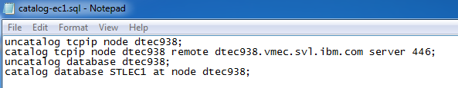

- Change the directory to the folder containing the shapefiles. Then, connect to the database STLEC1 using the following command
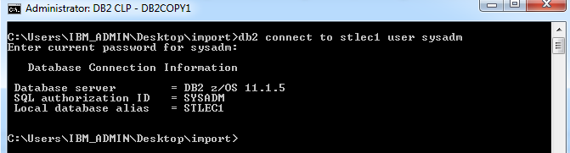

- FTP to your ec using sysadm account and then change the directory to tmp.
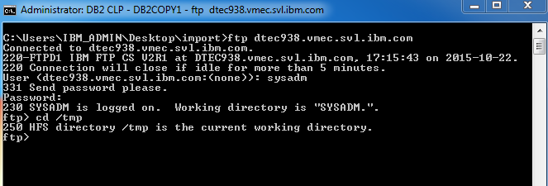

- Transfers the shapefiles into the tmp directory. Note: Use binary mode DO NOT TRANSFER the .prj file to avoid comparing the srs, created in the database and srs specified with the shapefile.
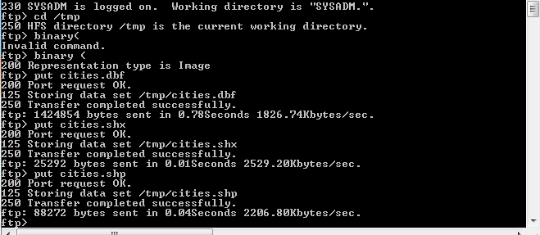

- Type quit to get out of ftp then run the script to create a new Spatial Reference System (SRS). The command to run the script is “db2 –tvf create_srs4326_z.sql”. Note: SRS4326 is the most common coordinate system.
db2 call SYSPROC.ST_Create_srs( 'SRS_4326' , 4326, -180.0, 5000000.0, -90.0, 5000000, 0, 1000, 0, 1000, 'GCS_WGS_1984', 'EPSG4326', ?, ?) ;

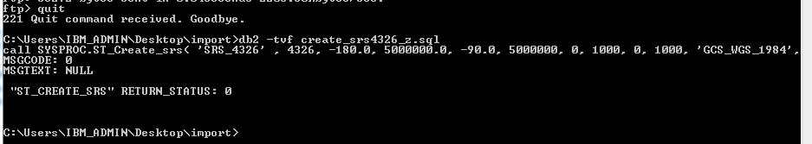

- Run the script the import the shapfile we just transfer to the tmp folder in the EC machine. Notes: Modify the command to match the shapefile
db2 drop table SYSADM.cities;

db2 call SYSPROC.ST_IMPORT_SHAPE( '/tmp/Cities.shp', NULL, 'SRS_4326' , 'SYSADM', 'CITIES', NULL, 1, NULL, 'SHAPE', NULL, NULL, NULL, 'OBJECTID', 1, NULL, 1000, '/tmp/spatialExcpMessag1.txt', '/tmp/spatialShapmessage.msg', ?, ?) ;

db2 call SYSPROC.st_register_spatial_column('SYSADM', 'CITIES', 'SHAPE', 'SRS_4326' , ?, ?);

db2 select varchar(db2gse.st_astext(shape),40) from SYSADM.cities fetch first 5 rows only;

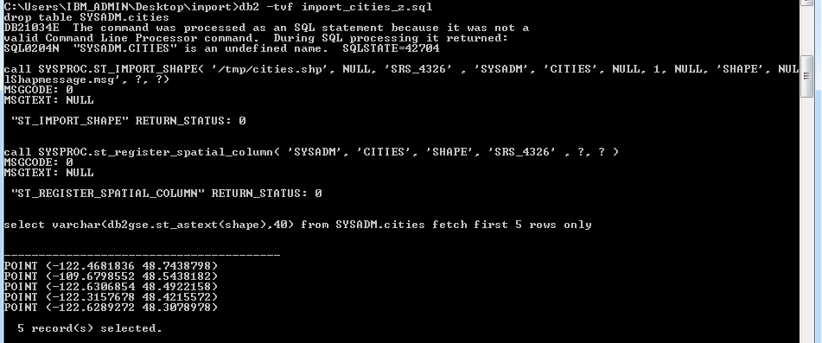
DONE!!!

